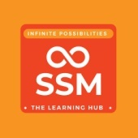

**SSM Institute of Engineering and Technology**

**NDLI Club of SSMIET - Library**

**Discussion Forum on ‘Online Education’**

**24-11-2022**

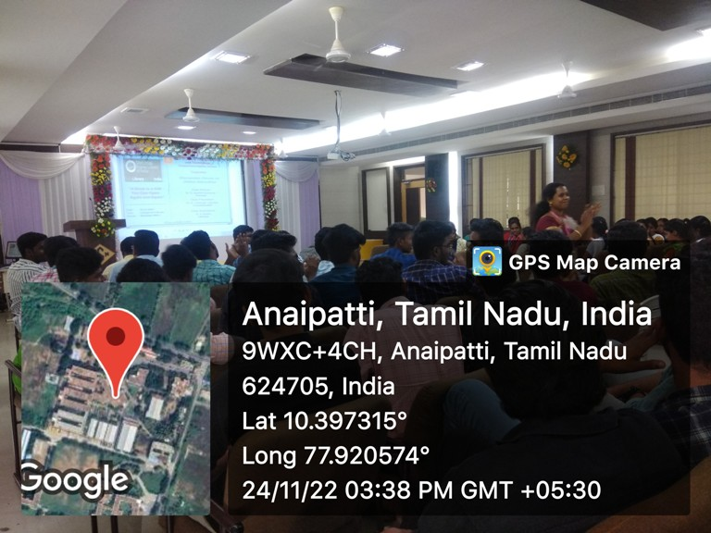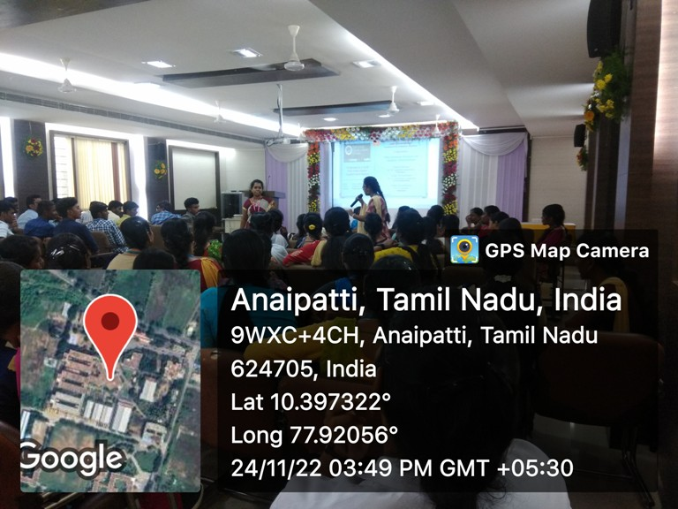**SSMIET – NDL Club** conducted a Discussion Forum on **Online Education** on 24th November 2022. The aim of this programme is to make the students more familiar with the merits and demerits of Online Education. This programme was organized by the Librarian of the college Dr. K.Sudha (NDL Club Secretary). Overall the event was an informative and interesting one. Students are eagerly involved in this event and register their opinion with enthusiastically.

